 | 19.4 Editors - Driver Editor - Footer tools and options
Table of content
Introduction 2

Introduction

This chapter here is about the tools and options elements in the footer. It contains various elements and tools. This footer is shared across the animation editors. Dope Sheet, Graph Editor, Driver Editor and NLA Editor
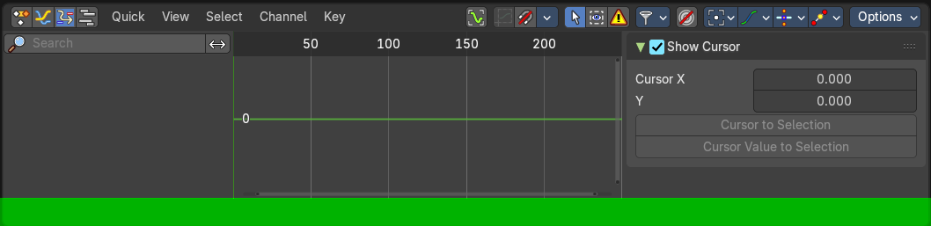
The footer in the driver editor has currently no content.

